Navigating My Way is a project being run by VMIAC.

The NDIS Quality & Safeguards Commission has given VMIAC the money for the project.

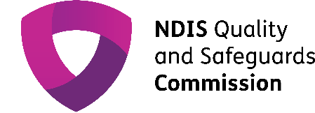
The NDIS Quality & Safeguards Commission is a group that works to make the NDIS better and safer.

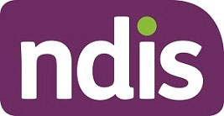
They do this by working with people on the NDIS and services that help people on the NDIS.

The Navigating My Way Project is run by and for people who have psychosocial disability.

Psychosocial disability means being disabled by mental health conditions.
You can also join this project if you have used mental health services before.

The goal of the project is to help us get what we need from the NDIS.
You will be invited to help make resources and information for people on the NDIS as well as NDIS services.

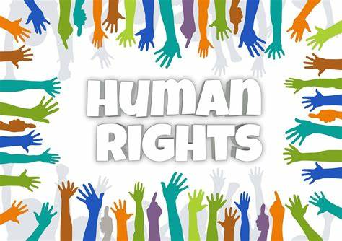
These resources will be about:

- understanding your rights,
- how to speak up for yourself, and,
- how to understand the NDIS.

The project started in September 2023 and will end in June 2025.

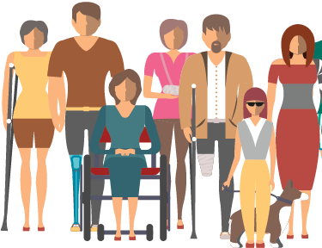
The project cares about:

- people with lived experience,
- designing the resources ourselves, and

- supporting speaking up for yourself.

People with psychosocial disability will help the team make the resources from November 2023.

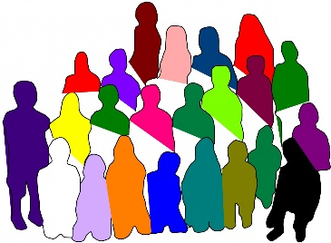
There will be an Advisory Group for the project.
The Advisory Group will have 10 people with psychosocial disability.

An Advisory Group is a group of people who share their ideas to help guide a project.
We will also run 10 group ‘co-design’ sessions with 5 people in each group.
These sessions will be run between December 2023 and June 2024.

These sessions will talk about:
- what your needs are,
- what you want,
- what your rights are in the NDIS, and
- what you want to make.

After these 10 sessions, we will make 2 groups of resources.

One group of resources will be for people with psychosocial disability.

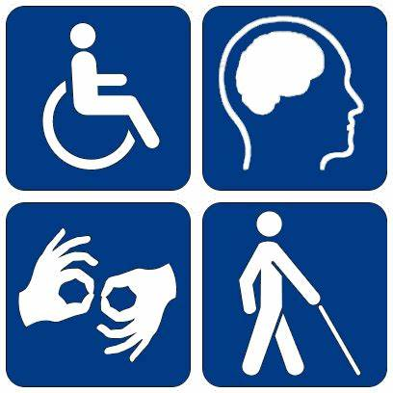
The other group of resources will be for people and groups who work with the NDIS.

